SCM Notes | Week 1, Session 4: Introduction to Platform Economy
Course: Supply Chain Digitization
0. Quick Recap — Last Session
- SC = complicated due to:
  - Many players & many transactions
  - Poor visibility of information across the chain
  - Need for decision-making at each node
- Every player (buyer / seller / intermediary) needs to: search, evaluate, decide

1. Why Platform Economy? — The Problem Statement

Core Problem
Def: Inefficiency in a supply chain occurs when the right information does not reach the right player at the right time — causing missed transactions and lost value.

Example 1 — Customer looking for a spice (B2C, information gap)
- Customer in Rajasthan wants to cook a specific dish requiring a rare spice
- Spice NOT available locally
- Customer's options (without info):
  - Cook without the spice
  - Substitute with another ingredient
- Missed opportunity: The need is not met
  - Spice IS available in Delhi — but customer doesn't know
  - Had the customer known → could have: called vendor, ordered delivery, or travelled to Delhi
Root cause of the problem:
- Information about availability not visible to the buyer
  - Value not created → inefficiency in value chain

Example 2 — Compressor Manufacturer (B2B, reach & transaction cost)
- Company XYZ: makes high-quality compressors; wants to sell internationally
- Approach: send salespersons to international exhibitions
- Process:
  - Demo product at exhibition → network → convince mid-size manufacturer
  - Multiple rounds of negotiation, site visits, bidding process
  - Result: 1 sale made after long process
- Problem:
  - 1 sale only → cannot break even (low volumes)
  - Need more exhibitions + more salespeople → very high cost of customer acquisition
Missed opportunity:
  - If XYZ could reach MORE buyers faster → more volume, better negotiating power
  - Constraint = inability to scale outreach efficiently

Example 3 — Food Delivery / Last Mile (B2C, matching & decision problem)
- Setup: company making same-day delivery (or 10-minute delivery) from cloud kitchens
- Customer orders 2 different items from 2 nearby cloud kitchens (e.g., main dish + dessert)
- Company sends 2 separate delivery partners → 2 separate doorbell rings

- Problems created: (although the need is met)
  - Customer unhappy → service quality issue (poor experience)
  - May stop ordering from one cloud kitchen in future → revenue loss
  - May switch to a competitor entirely → customer loyalty lost
  - Both delivery partners occupied → another customer gets no delivery → another lost transaction
Missed opportunity:
- One delivery partner could have picked up BOTH items (nearby kitchens!)
  - Other partner could serve the second customer

Root cause: Lack of information visibility + poor matching/assignment decision

2. Common Thread Across All 3 Examples
Example | Problem Type | Core Issue
Spice (B2C) | Information gap | Buyer unaware of supplier
Compressor (B2B) | Reach & transaction cost | Seller can't scale outreach
Food delivery (B2C) | Matching / assignment | Wrong resource → wrong order
- All problems boil down to 2 things:
  - Visibility of information (who has it? who needs it?)
  - Decision-making quality (right resource → right customer/supplier)
  - These gaps → missed opportunities → value not created → inefficiency
  - Need for an intermediary → a PLATFORM

3. Platform Economy — Concept

What is a Platform?
Def: An intermediary (physical or virtual) that makes business information visible to multiple players and connects them to enable transactions.
- What a platform provides:
  - Visibility of players (buyers, sellers, service providers, govt bodies, financial institutions)
  - Visibility of prices
  - Visibility of product / service characteristics (e.g., product images, ratings, reviews)
  - Visibility of locations
- What a platform enables:
  - Faster decision-making
  - Reduces unnecessary interactions and biases
  - Players feel safe to transact with unknown parties
  - Social AND economic transactions (not just buying/selling)

Multisided Platform
Def: A platform that caters to several types of players (sides) simultaneously — e.g., buyers, sellers, logistics providers, financial institutions, all on one platform.
  - All parties must be affiliated/registered with the platform
  - Affiliation → provides security and identity verification for all participants

4. Examples of Platform Economy

A. Traditional (Offline) Platforms
Platform | Why it is a platform
Local markets, Local shops | Multiple buyers & sellers meet at one location; social + economic transactions
Matchmaking (marriage broker) | Intermediary reviews profiles (groom/bride), evaluates parameters, suggests matches
⚠ Traditional platforms = primarily offline, in-person interactions

B. Digital Platforms
Platform | Type | What it does
Amazon, Flipkart | B2C e-commerce | Buyers, sellers, logistics, payment all on one platform
Ola, Uber | Aggregator | Matches drivers with customers/commuters
Facebook | Social (+ marketplace) | Primarily social; marketplace for economic transactions also
Shaadi.com (In India) | Digital matchmaking | Traditional matchmaking digitized; similar concept globally
Ariba (SAP) | B2B | Companies connect with suppliers for procurement
GEM (Govt. e-Marketplace) | B2G / B2B (India) | Govt + private entities purchase products; decision support tools included

5. Key Features of Digital Platform Economy
- Platforms are virtual → enable both online + offline transactions (hybrid)
⚠ E.g., pay online via UPI OR pay delivery partner in cash on delivery
- Provide decision support tools → e.g., "similar products" recommendations on Amazon
- Members must be registered/affiliated → platform ensures basic security & trust
- Sellers can pay the platform to promote/advertise products
- Multiple parties on one platform: customers, sellers, logistics, financial institutions, tech providers

Players in a Digital Platform (e-commerce example)
  - Customer logs in → sees products → makes purchase decision
  - Seller → demonstrates and promotes products on platform
  - Platform matches seller to buyer → one or more logistics partners handle physical delivery
  - Financial institution → enables digital payment (transparent to all parties)
⚠ All players need affiliation/login → platform provides security layer
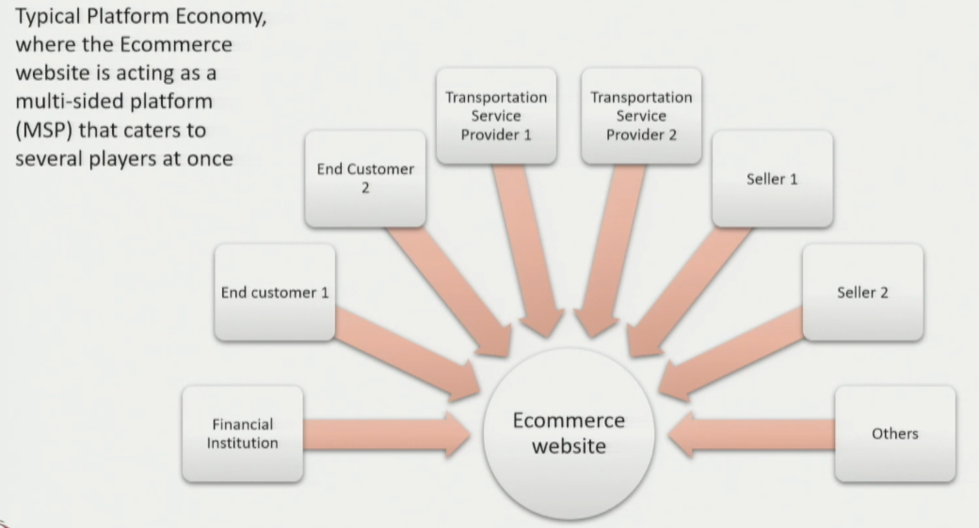

6. Summary — Platform Economy at a Glance
KEY TAKEAWAY: A platform economy connects multiple players (buyers, sellers, service providers, institutions) through a physical or virtual intermediary — making information visible and enabling faster, safer, scalable transactions.

- Solves: information asymmetry, poor matching, high transaction costs
- Enables: social + economic transactions, online + offline (hybrid)
- Key concept: multisided platform — one platform, multiple types of participants

✓ EXAM ANGLE: "Explain the need for platform economy in supply chains with examples." → Use all 3 examples (spice / compressor / food delivery) to show the 2 root causes: information gap + decision mismatch. Then define platform economy, its features, and give examples (Amazon, Ariba, GEM, Ola, Shadi.com). Mention multisided platform for extra marks.

